The following figures are very much interrelated since one among them will show how the created test is maintained in the database while others will show how test questions, and test cases are maintained in the backend.

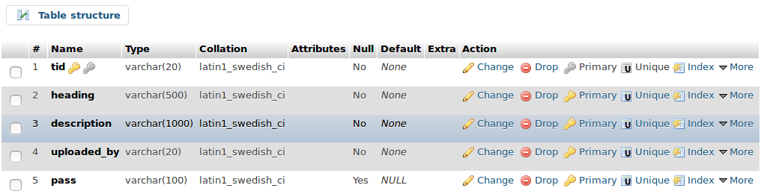

Fig. 4.13: Test Created

As it can be seen from the above figure that a separate table is maintained for storing the details of the test created by the User (teacher) and a field is maintained to show which user has created that test.

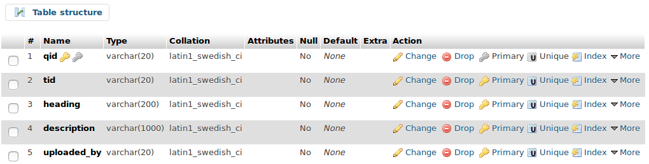

Fig. 4.14: Test Questions

This figure is showing the table which is maintained for storing the complete details in respect of a question published by any teacher which is useful for both the student and the administrator.